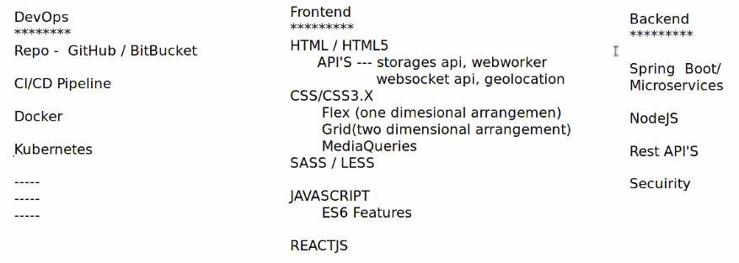
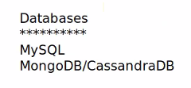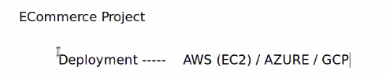

Github
=============
Code colaboration tool or appication collaboration tool.

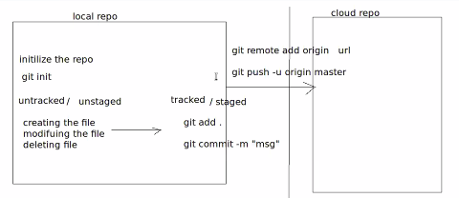

Auto save option is mandatory in while working with projects.
In VS (visual studio)-> setting-> auto save.
->setting-> font size

Download and install git: https://git-scm.com/downloads/win

Sending files from local system to GIthub cloud
=============*********=================
Create New Repository in github
Then copy cloud URL (link) https://github.com/klngithubsairam/JFSD-FED.git

https://github.com/klngithubsairam/collaborative-repo.git

Create new folder in local system, then open terminal to the this folder
And type $code .(dot) to open visual studio
Open terminal(by click on three dots) in VS and open command prompt(by click on ^) :
$ git config --global user.name “github username-klngithubsairam”
$ git config --global user.email “kodavali.lakshmi@gmail.com”
$git commit -m “file created”
$git remote add origin cloud-url- link
$git push -u origin master
$

============****************============

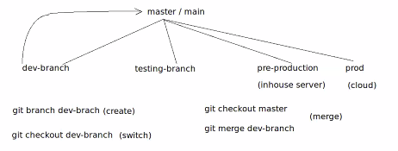

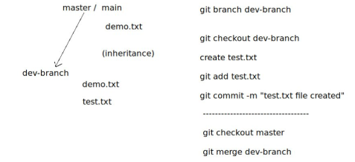

Open VS in the folder JFSD-REPO in the commad prompt
$git branch
Git branch dev-branch
Git branch
Git checkout dev-branch (To switch to dev-brach folder)
Create a file in VS manually test.txt and write some thing (Git add text.text
)
Git commit -m “test.txt”
Git branch
To push into GIthub:

Git add .
Git commit -m first.html or Git commit -m .
Git push -u origin main (To push in to github)
Refresh github to see updated files

HTML

<!DOCTYPE html> //It represents html version. It validates the html code. Only browser can understand this DOCTYPE.

<!DOCTYPE html>
<html>
<head>
<meta http-equip="refresh" content="1">
</head>
<body> This first html file </body>
</html>

To execute this code from VS, click on extension symbol and then type and install “Live Server”.

Then In the Live Server Screen, right side bottom there is a option called “Go Live” initially, later it will show “port number” in the place of “Live Servrer”.

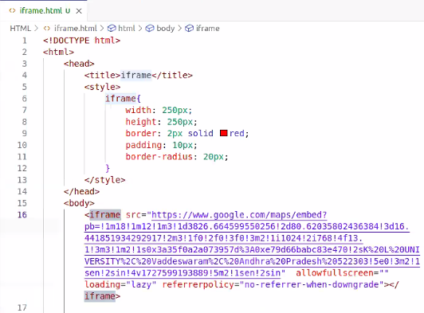

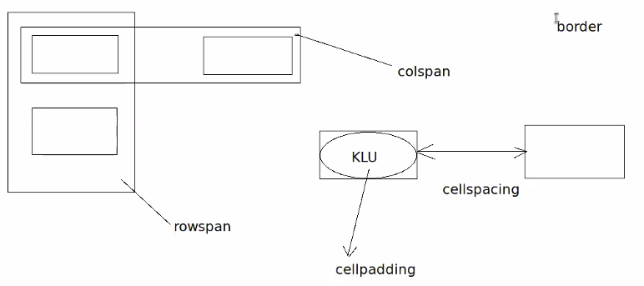
<table> </table>
<tr> </tr>
<td> </td>
<!-- HTML comments-->

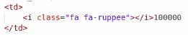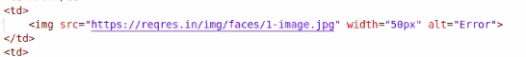
Note: Add snippet (html/css/javascript snippet) to get shortcuts while typing.

Psuedo Classes
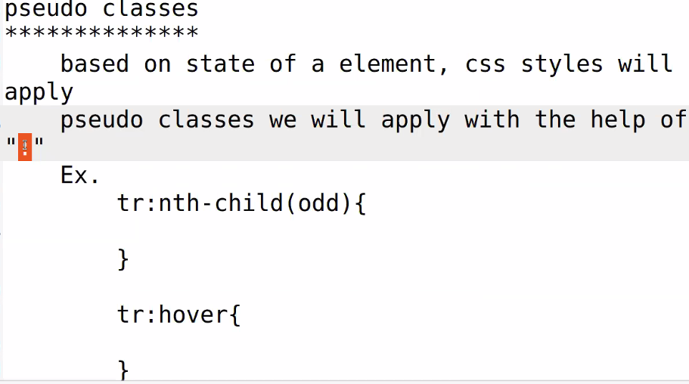
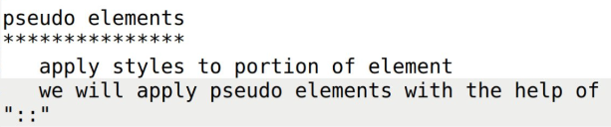
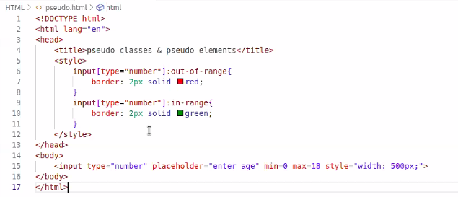

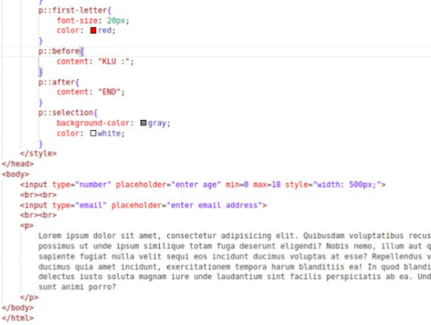

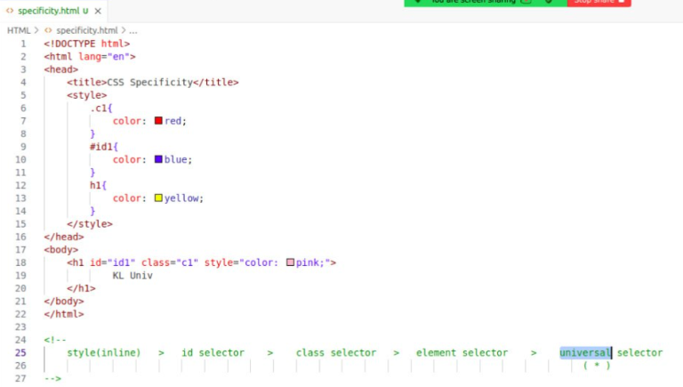

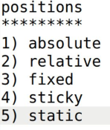
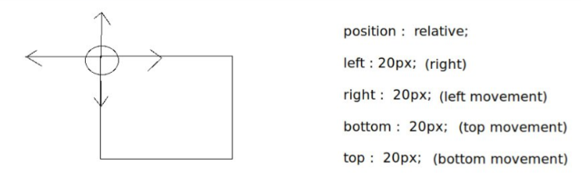
With relative position, other elements will not get distrurb.

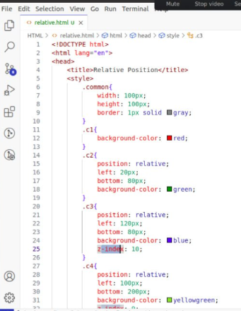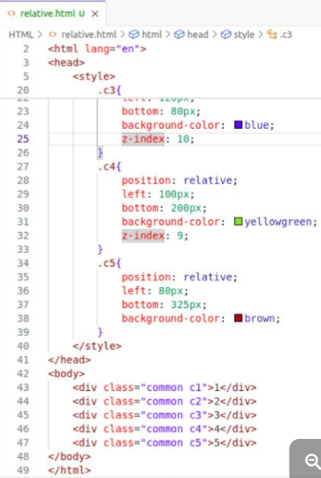

Default font-size is: 16px
Font-size: 2rem; //means 2*16=32px
Percentage font-size is depending on the nearest parent tag font-size.
Dimentions types: (rem, em, px, vw and vh )

Collaborations Demo in Git hub:

Create a collaboration-Repo file in github,
Go to settings -> collaborations -> Give Password
Add collaboration people email-id’s to add as a collaborators.

Then collaborator receive mail, from there they have to accept it.
